**ICS Team #9 Project report**

**Problem**

The question is to develop a card matching memory game using JavaFX. It requires to display the cards in 4 x 4 grid view. The player should click on the card to view it then he should match it with another card. If they are matched, they will remain displayed. If they are not, they will be flipped. If the player played another game, the card will be shuffled. While playing the game there will be a timer that display time spent for each round. The game will contain sounds for matching and non-matching to make the game more interesting. It also contains a list for the top scores to make the game more challenging.

**Solution**

We planned how do we develop the game and we decided to make five classes. Main class, CardPane class, PlayCard class, Scores class and Timer class.

Main class: -

* The Main class is for the front end.
* It contains all the front-end code except the cards, they are created in the CardPane class.

CardPane class: -

* The CardPane class is for displaying, arranging and shuffling the cards.
* It contains one method ( resetAll()) that resets all the cards to the initial state (not matched and flipped).

PlayCard class: -

* PlayCard class is for flipping the cards, animations and comparing between them.
* It contains the handler for the animation and the setOnMouseClicked for the card and the comparing method (isMatchedByPixels).

Scores class: -

* Scores class is for calculating the scores and save them.
* Special formula for scores was created to make the game more competitive.
* It contains: -
  + startingButton: starts calculating the scores.
  + NextButton(): reset the Timer, roundMoves and Increments the round count by one for each round.

Timer class: -

* Timer class is for making a timer.
* It contains one method to format the time to mm: ss.

We added some animations to make the game more interesting.

**Screenshots**

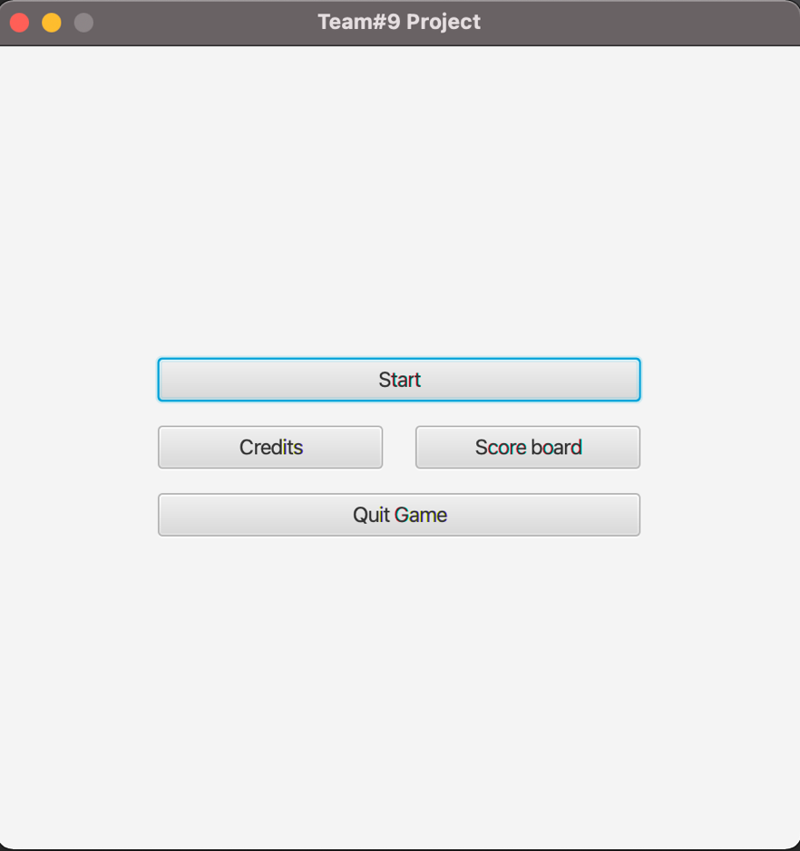

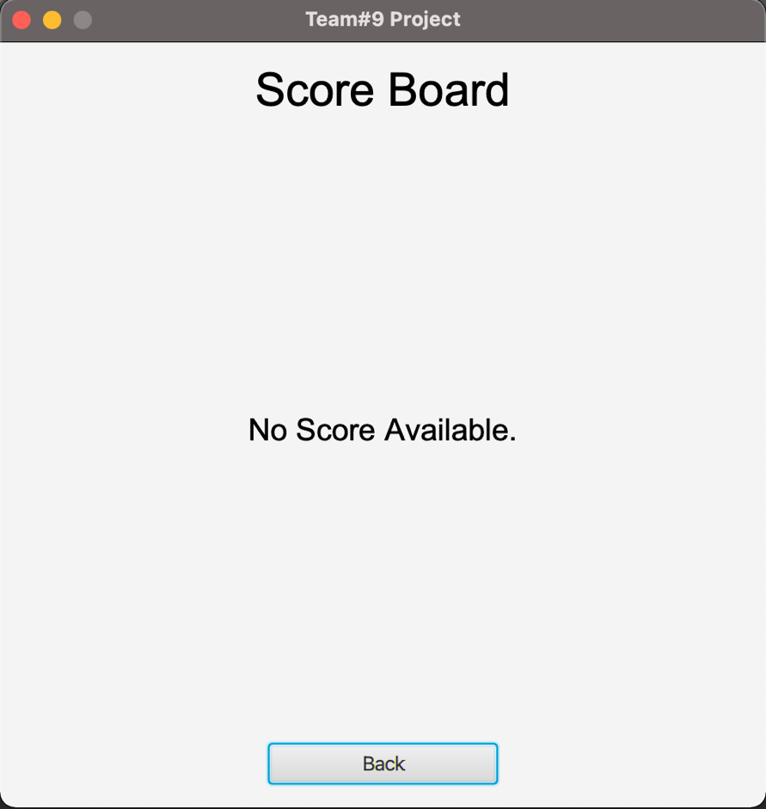

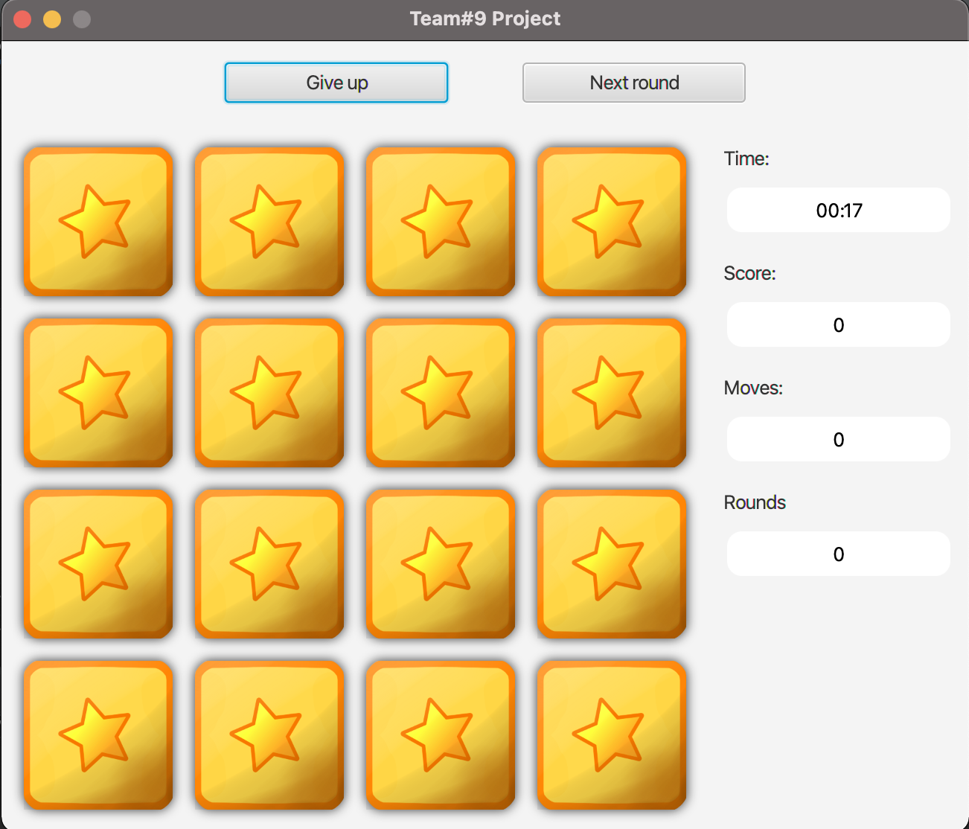

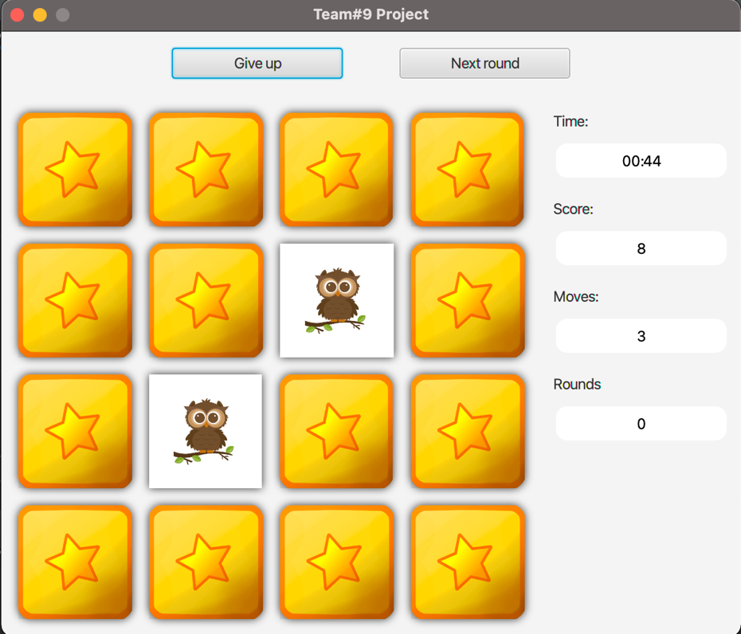

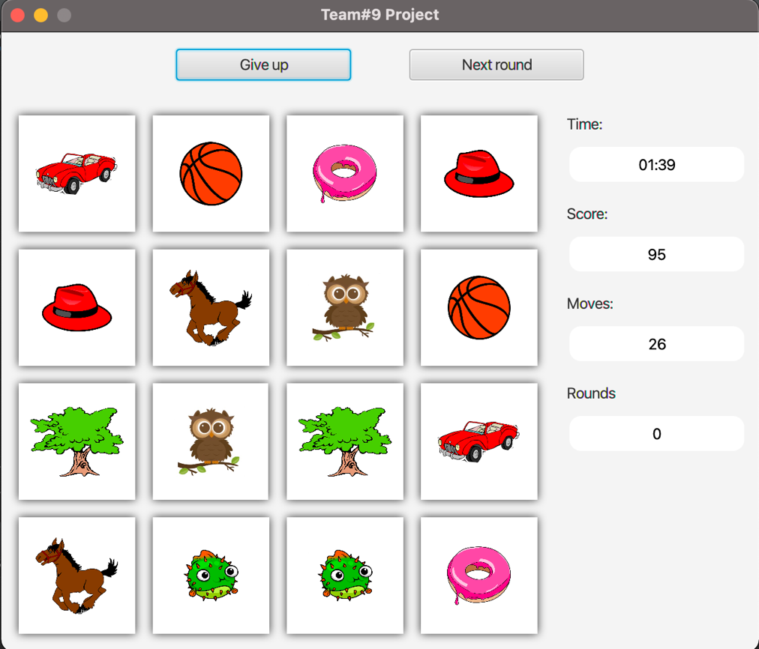

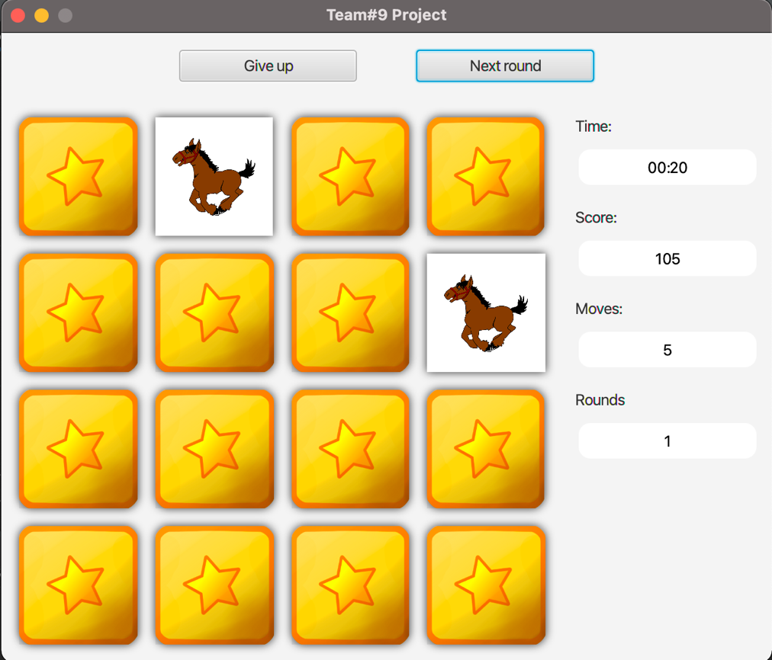

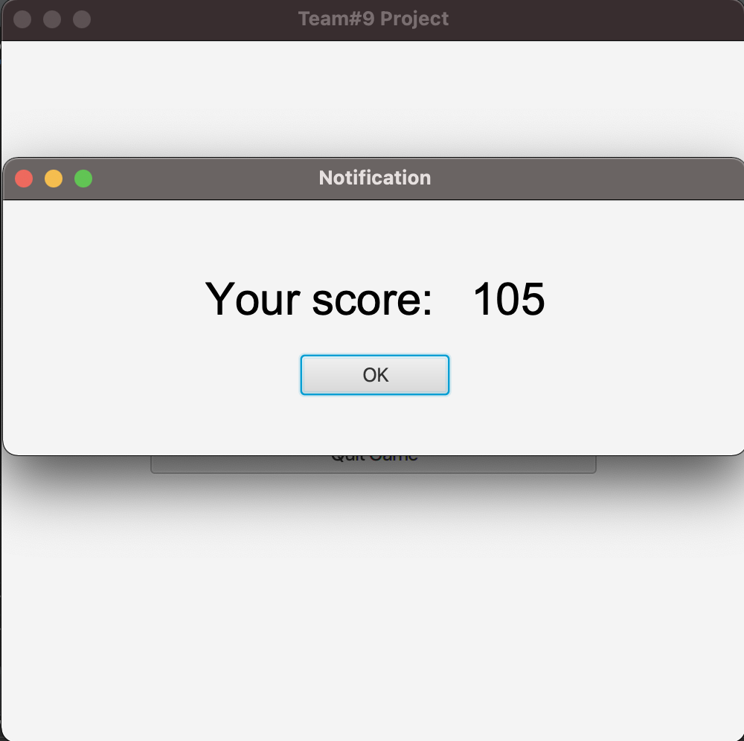

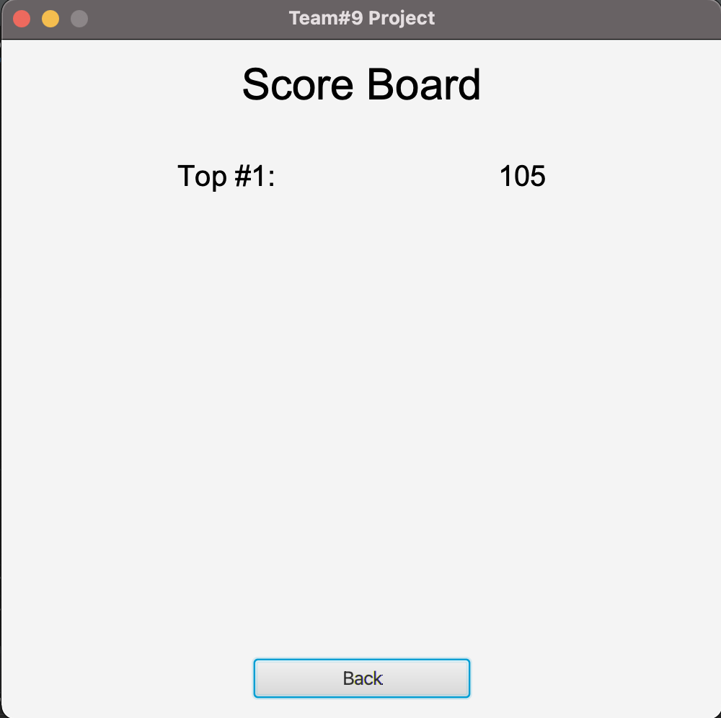

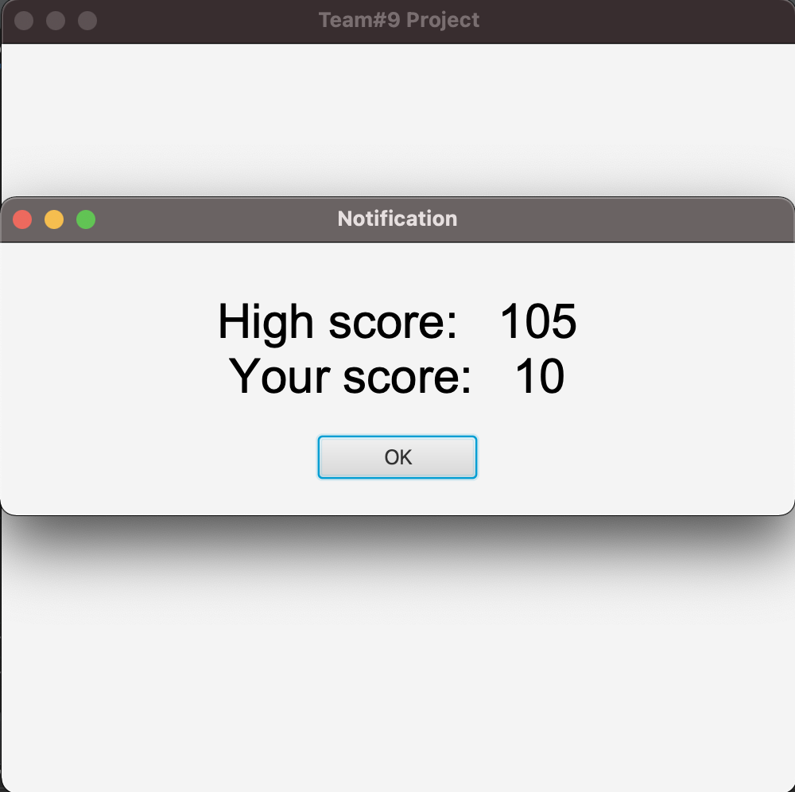

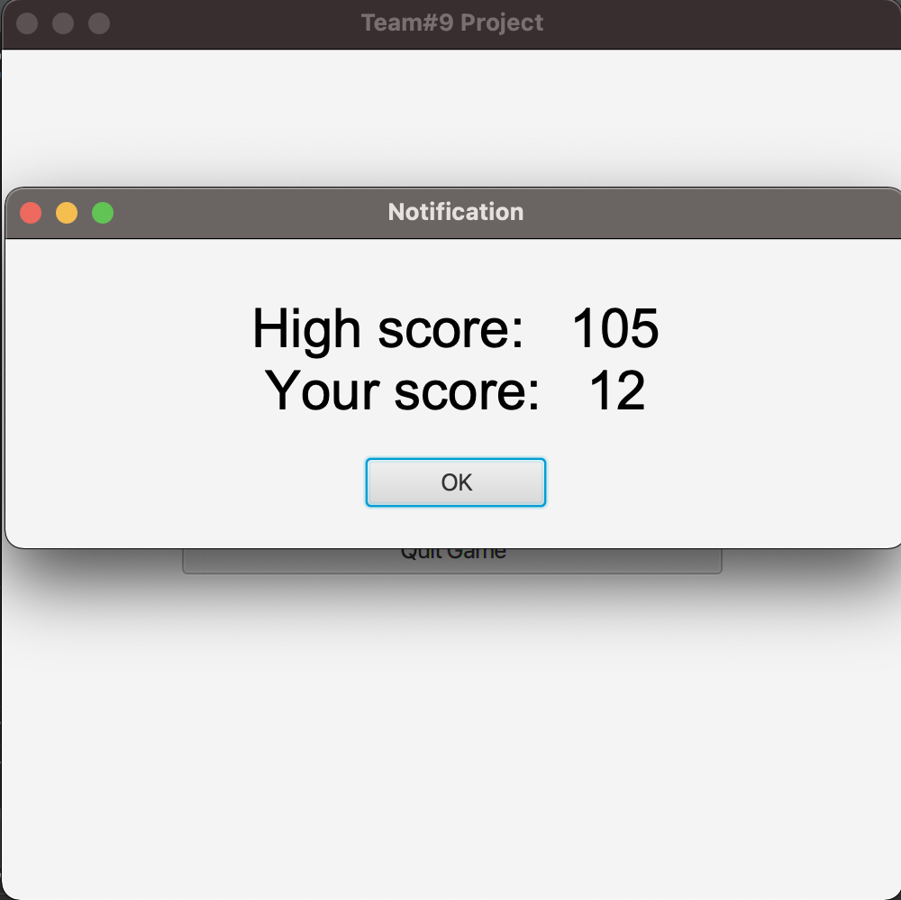

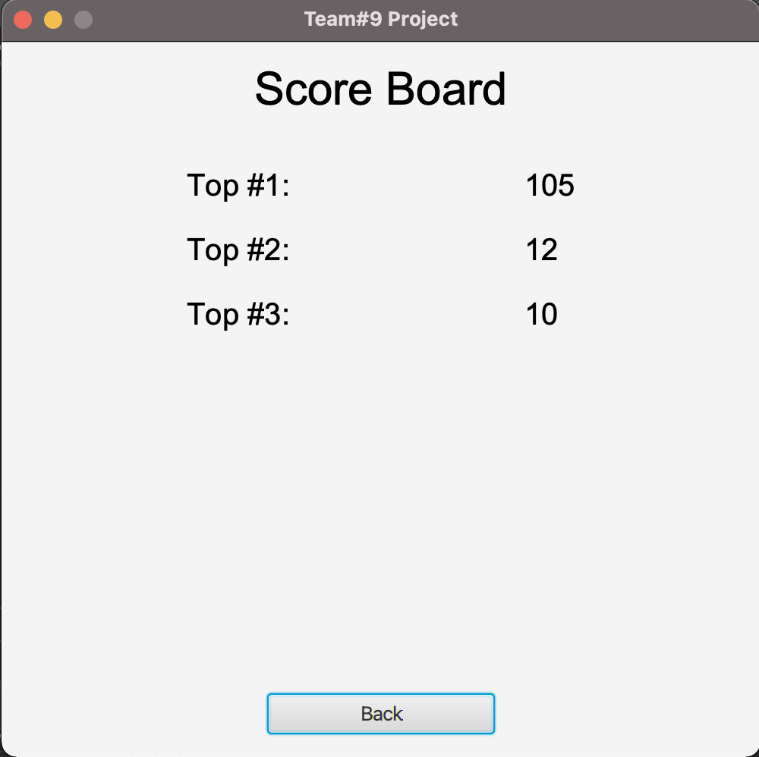

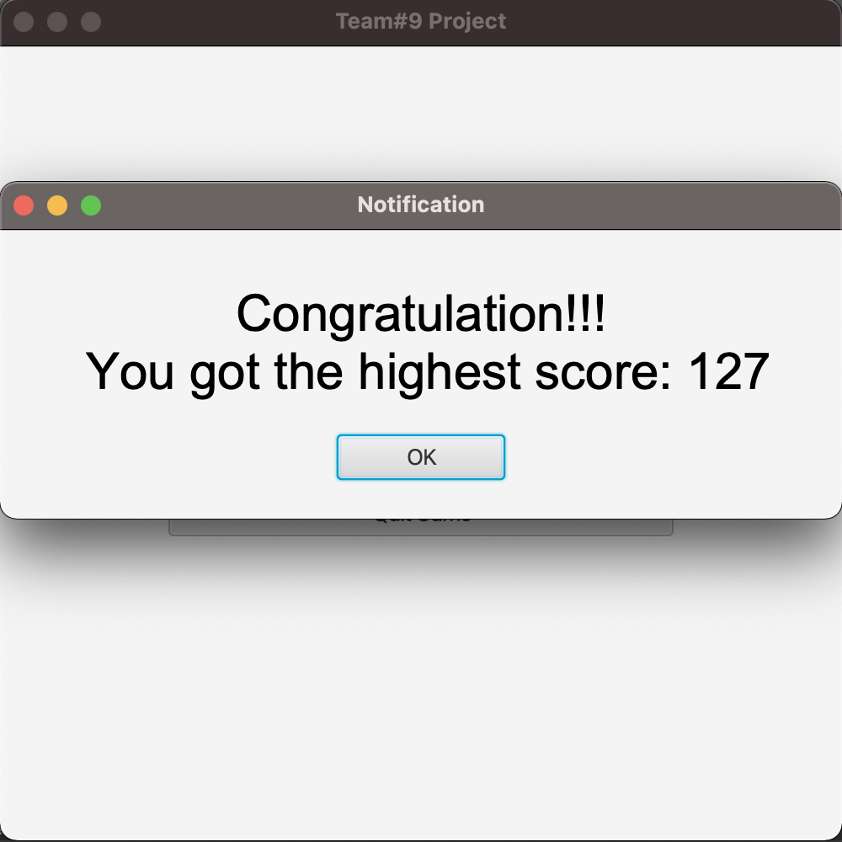

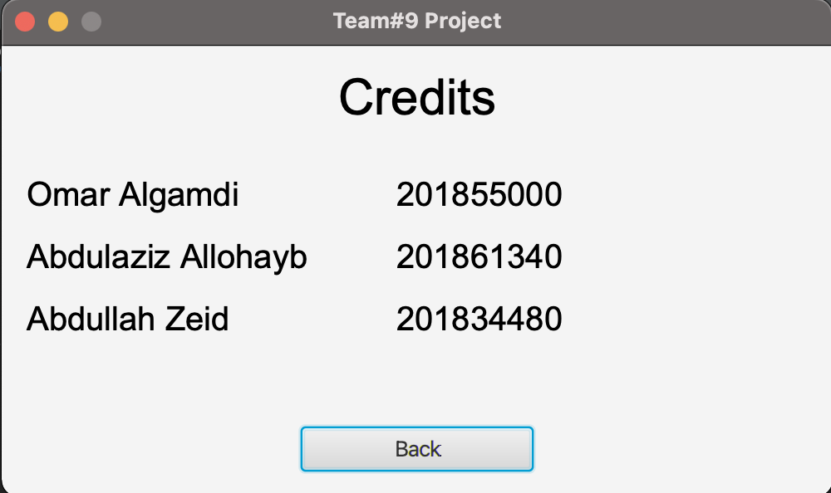

**Work distribution**

Omar Alghamdi 40%

Abdulaziz Allohayb 30%

Abdullah Zeid 30%